Lab 7: Functions
This lab accompanies Chapter 6 of Starting Out with Programming Logic & Design.

Dedicate
Name: ___________________________

Lab 7.1 – Functions and Pseudocode

Critical Review

You have been coding with modules in pseudocode and functions when using Python.

You modules in pseudocode can be made into functions by returning a value.

A function is a special type of module that returns a value back to the part of the program that called it.

Most programming languages provide a library of prewritten functions that perform commonly needed tasks.

Library functions are built into the programming language and you can call them as needed. They are commonly performed tasks.

Help Video: View video: Lab 7.1

Writing Your Own Function that Returns an Integer
Step 1: A function contains three parts: a header, a body, and a return statement. The first is a function header which specifies the data type of the value that is to be returned, the name of the function, and any parameter variables used by the function to accept arguments. Remember that a parameter is a definition of an incoming value used in the function header. An argument is the value passed into the function when it is called. The body is comprised of one or more statements that are executed when the function is called. In the following space, complete the following: (Reference: Writing Your Own Functions, page 233).
Dedicate

- Write a function with the header named multiplyFive.
- The function will accept an Integer parameter variable named product.
- The function body will ask the user to enter a number into the product variable and multiply the number by five. The answer will be stored in the variable product.
- The return statement will return the value of product.

Function a.multiplyFive(b. Int ref product)
Display “Enter a number:”
Input c. product
Set c. product = product * 5
Return d. product

Step 2: In the following space, write a function call to your function from Step 1.

Set product = multiplyFive(product)

Writing Your Own Function that Returns a Boolean Value
Step 1: A Boolean function will either return a true or a false value. You can use these functions to test a condition. They are useful for simplifying complex conditions that are tested in decision and repetition structures. In the following space, complete the following: (Reference: Returning Boolean Values, page 246).
Dedicate

- function with the header named singKaraoke.
- The function will accept a Boolean variable named sing.
- The function body will ask the user to enter whether they sing karaoke and determine if they do with an if statement
- The return statement will return the value of answer.

Function a. singKaraoke(b. Bool ref sing)
Declare String sing
Display “Do you sing karaoke? (yes or no):”
Input c. sing
If (c. sing == “no”) then
answer = False
Else
answer = True
End If

Return d. answer

Step 2: In the following space, write a function call to your function from Step 1.

Set answer = singKaraoke (sing)

Using Mathematical Library Function: sqrt
Step 1: The sqrt function accepts an argument and returns the square root of the argument. In the following space, complete the following: (Reference: The sqrt Function, page 248).
Dedicate

- Declare a variable named mySquare and a variable named rootAnswer of the data type Real.
- Ask the user to enter a number of which they want to find the square root. Store the input in mySquare.
- Call the sqrt function to determine the square root of mySquare.
- Display the square root to the screen.

Declare Integer a. mySquare
Declare Real a. rootAnswer
Display “Enter a number:”
Input b. mySquare
Set c._rootanswer__ = __sqrt(mySquare)___
Display “The square root is”, d. rootAnswer

Using Formatting Functions
Step 1: Most languages provide one or more functions that format numbers in some way. A common use of formatting functions is to format numbers as currency amounts. While a specific programming language will have its own name for formatting currency, use the function currencyFormat for pseudocode. In the following space, complete the following: (Reference: Formatting Functions, page 254).
Dedicate

- Declare a variable named cost, a constant variable named profit set to the rate of .26, and a variable named price.
Dedicate
- Ask the user to enter the cost. Store the input in cost.
- Calculate the price as cost + cost * profit.
- Make a call to the currencyFormat function and pass it price. Since you are not displaying it on this line, simply set the return value to price.
- Display the price to the screen.

Declare Real a. cost
Declare Constant Real a. PROFIT
Declare Real a. price
Display “Enter the cost:”
Input b. cost
Set c. price = cost*profit
price = d. currencyFormat(price)
Display “The price is $”, e. price

Lab 7.2 – Functions and Flowcharts

Critical Review

When creating a flowchart for a program that has functions, draw a separate flowchart for each function.

The starting terminal symbol usually shows the name of the function, along with any parameters that the function has.

The ending terminal symbol reads Return, followed by the value or expression being returned.

In Raptor, there are built-in procedures and functions that perform a wide variety of tasks on the programmer's behalf, saving development time and reducing the chance for errors.
Raptor's buily-in functions can return values, but modules made by the user do not have that ability.

Raptor has the following built-in functions.
basic math: rem, mod, sqrt, log, abs, ceiling, floor
trigonometry: sin, cos, tan, cot, arcsin, arcos, arctan, arccot
miscellaneous: random, Length_of

If you want to learn what each of these functions do, use the Help menu in Raptor and search for the function name.

While ceiling and floor round a number to the nearest integer, there is no function in Raptor that will round a number just to two decimal places.

The random function in Raptor takes no arguments. To generate a random integer from 1 to n, use floor((random*n) + 1). For example, you can simulate the roll of a die (random number from 1 to 6) with floor((random * 6) + 1).

Help Video: View video: Lab 7.2

This lab requires you to create the flowchart from page 230 on Using Random Numbers using the RANDOM function. Use an application such as Raptor or Visio.
Dedicate

Step 1: Start by reading the pseudocode on page 229 and 230 of your textbook on Using Random Numbers. In addition to simply displaying the random values, your program will also meet the following requirements:
- Allow the two players of the dice game to enter their names in variables named userOne and userTwo.
- Based on the random roll of the dice, your program will determine which value is higher or if they tie and declare one player a winner.
- Create structure in your program by creating the following modules:
  - An inputUsers( ) module that will ask the players to enter their names
  - A randCalc( ) module that will call the RANDOM function and determine the winner. This will be done with a decision statement.
  - A outputInfo( ) module that will print the winners name to the screen.
- Additionally, your program should allow the same players to play as many times as they want.

Step 2: Start Raptor and save your document as Lab 7-2. The .rap file extension will be added automatically.

Step 3: Start by adding a comment box with the necessary variables.

Step 4: Add your loop to run multiple times and your module calls in the main module. Your flowchart might look as follows:
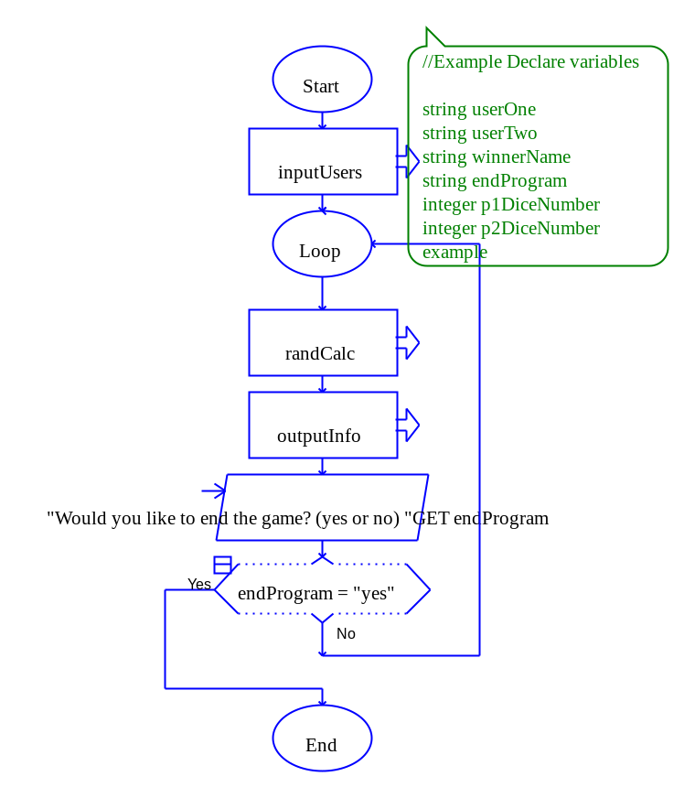
Step 5: Code the inputUsers( ) module so both users can enter their name into the appropriate variable.

Step 6: Go to the randCalc( ) module and add an assignment statement. Assign p1DiceNmber to whatever the RANDOM function return. The assignment box input box should look as follows:
Dedicate

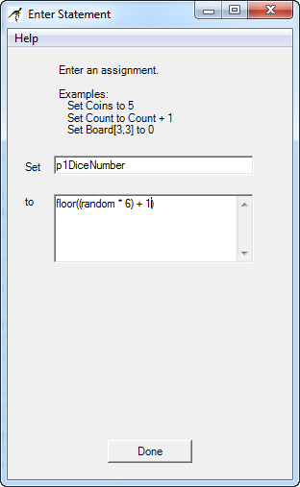

Step 7: Add a second assignment statement and do the same for p2DiceNumber.

Step 8: Add a selection statement that will determine which number is larger, or if there is a tie. The best way to do this is to create a nested if else where you first check to see if p1DiceNumber is equal to p2DiceNumber. If so, assign winnerName equal to “TIE GAME”. If not, create a second decision to see if p1DiceNumber is greater than p2DiceNumber. If so, then winnerName should be set equal to userOne and if not then winnerName should be set equal to userTwo.

Step 9: Go to the outputInfo( ) module and print the winners name to the screen.

Step 10: Paste your finished flowcharts in the space below.

PASTE FLOWCHART HERE

Lab 7.3 – Python Code and Random
Critical Review

A value-returning function is a function that returns a value back to the part of the program that called it. In Python, you have been using value-returning functions and those that do not.

Recall the function calls from Lab 6-4. The first call returns weeks back to the number weeks. The printTotalPay call just displays a value and there is no need to return a value.

weeks = getWeeks (weeks) #value returning function
printTotalPay (totalPay) #function returns no value

Standard Library Functions
Python comes with a standard library of functions that have already been written for you. These functions, known as library functions, make a programmer’s job easier because they perform many of the tasks that programmers commonly need to perform. In fact, you have already used several of Python's library functions. Some of the functions that you have used are input, raw_input, and range. Python has many other library functions.

The random Function
In order to use the random function in Python, you must import the random library. This loads the library into memory so that you can use the functions that exist within it. To do this, simply add the following line to the top of your code:
import random

One of the functions in the random library is the random.random.int( ) module. This module accepts two arguments with the first being the starting number and the second being the ending number. The following is how you would get a random number between 1 and 6.

p1DiceNumber = random.randint(1, 6)

Writing your own Value-Returning Functions
We have already written our own value returning functions that return one variable to the place where the function was called.

However, you can also return more than one value in Python. The function call might look as follows:
userOne, userTwo = inputNames(userOne, userTwo)

The return statement looks as follows:
return userOne, userTwo

Help Video: View video: Lab 7.3

The goal of this lab is to convert the Dice Game in Lab 7.2 to Python code.

Step 1: Start the IDLE Environment for Python. Prior to entering code, save your file by clicking on File and then Save. Select your location and save this file as Lab7-3.py. Be sure to include the .py extension.
Dedicate

Step 2: Document the first few lines of your program to include your name, the date, and a brief description of what the program does.

Step 3: Start your program with the following code for main:

#Lab 7-3 The Dice Game
#add libraries needed

#the main function
def main():
print
#initialize variables

#call to inputUsers

#while loop to run program again
while endProgram == 'no':

#initialize variables

#call to randCalc

#call to outputInfo

endProgram = raw_input('Do you want to end program? (Enter yes or no): ')

#this function gets the users names

#this function will get the random values

#this function displays the winner

# calls main
main()
Step 4: Under the documentation for adding libraries, add the following statement:

import random

Step 5: Under the documentation for initialize variables, set endProgram to ‘no’ and userOne and userTwo to ‘MISSING NAME’.

Step 6: Under the documentation for making a call to inputUsers, set the function call to both userOne and userTwo and pass both variables to the function as arguments. This must be done because both values need to be returned from the function. This is done as follows:

userOne, userTwo = inputUsers(userOne, userTwo)

Step 7: Inside your while loop, set winnerName to ‘MISSING NAME’ and p1DiceNumber and p2DiceNumber to 0.

Step 8: Make a call to randCalc and pass the necessary variables needed in this function. This function should be set to the winnerName as that variable will be returned from the function. This is done as follows:

winnerName = randCalc(p1DiceNumber, p2DiceNumber, userOne, userTwo, winnerName)

Step 9: Make a call to outputInfo and pass it winnerName.

Step 10: The next step is to write the function that will allow both players to enter their names. Write a function heading that matches your function call in Step 6, making sure to accept two arguments. The body of this function will use the raw_input function to take in both players names, and one return statement that returns both userOne and userTwo variable The return statement should look as follows:

return userOne, userTwo

Step 11: The next function to code is the randCalc function. Write the function header to match the function call in Step 8. This function body will call the random function to determine p1DiceNumber and p2DiceNumber. The code should look as follows:

p1DiceNumber = random.randint(1, 6)
p2DiceNumber = random.randint(1, 6)

Step 12: Next, inside this function write a nested if else statement that will set winnerName to either userOne name, userTwo name, or “TIE GAME”.

Step 13: The final step in this function is to return winnerName.

Step 14: The final function to code is the outputInfo function. Write the function header to match the call made in Step 9. The body of the function should simply print the winnerName variable to the screen.

Step 15: Execute your program so that all loops work and paste the final code below

PASTE CODE HERE

Lab 7.4 – Programming Challenge 1 – Math Test

Write the Flowchart and Python code for the following programming problem based on the pseudocode below.

Help Video for Raptor: View video: Lab 7.4 Raptor

Help Video for Python: View video: Lab 7.4 Python

Write a program that will allow a student to enter their name and then ask them to solve a number of mathematical equations. The program should allow the student to specify the number of mathematical questions they wish to answer. The program should display two random numbers that are to be added, such as:

24
x 12

The program should allow the student to enter the answer. The program should then display whether the answer was right or wrong, and accumulate the correct values. After the specified number of questions are answered, calculate the average that were answered correctly. Then display the student name, the number correct, and the average correct in both decimal and percentage format.

In addition to any system functions you may use, you should consider the following functions:
- A function that allows the student to enter their name.
- A function that allows the student to enter the number of questions
- A function that gets two random numbers, anywhere from 1 to 99.
- A function that displays the equation and asks the user to enter their answer.
- A function that checks to see if the answer is right and accumulates the number right.
- A function that calculates the results.
- A function that displays the student name, the number of questions, the number right, and the average right.

Your sample output might look as follows (random numbers will be different):

Enter your Name: Katie
How many math questions would you like to answer?: 3
What is the answer to the following equation
42
x
28
What is the product: 472
Wrong

What is the answer to the following equation
16
x
23
What is the product: 368
Right

What is the answer to the following equation
28
x
45
What is the product: 1260
right

My name is: Katie
The number of questions I asked: 3
The number of questions I got right: 2
The average right is 0.667 or 66.7 %

The Pseudocode

Module main()
//Declare local variables
Declare Integer counter = 0
Declare Integer questions = 0
Declare String userName = “MISSING NAME”
Declare Real averageCorrect = 0.0
Declare Real correct = 0.0
Declare Integer randomNumber1 = 0
Declare Integer randomNumber2 = 0
Declare answer = 0.0

Set userName = getUserName(userName)
Set questions = getQuestionCount(questions)
//Loop to run program again
While counter < questions
//calls functions
Set randomNumber1, randomNumber2 = getRandomNumbers(randomNumber1, randomNumber2)
Set answer = askQuestion (randomNumber1, randomNumber2, answer)
Set correct = checkAnswer(randomNumber1, randomNumber2, answer, correct)
Set counter = counter + 1
End While
Set averageCorrect = getStatistic(correct, averageCorrect, questions)
Call outputInfo(correct, averageCorrect, userName)
End Module

Function String getUserName (String userName)
Display “Enter your Name:”
Input userName
Return userName
End Function
Module getQuestionCount(Integer questions)
Display “How many math questions would you like to answer?: “
Input questions
Return questions
End Module

Module getRandomNumber(Integer randomNumber1, Integer randomNumber2)
Set randomNumber1 = random(1, 99)
Set randomNumber2 = random(1, 99)
Return randomNumber1, randomNumber2
End Module

Function Integer askQuestion(Integer randomNumber1, Integer randomNumber2, Integer answer)
Display “What is the answer to the following equation”
Display randomNumber1
Display “x”
Display randomNumber2
Display “What is the product:”
Input answer
Return answer
End Function

Function Integer checkAnswer(Integer randomNumber1, Integer randomNumber2, Integer answer, Integer correct)
If answer == randomNumber1* randomNumber2 then
Display “Correct”
Set correct = correct + 1
Else
Display “Not Correct”
End If
Return correct
End Function

Function Real getStatistic (Integer correct, Real averageCorrect, questions)
Set averageCorrect = correct / questions
Return averageCorrect
End Function

Module outputInfo(Integer correct, Real averageCorrect, String userName)
Display “Information for user:”, userName
Display “The number your answered correctly:”, correct
Display “The average correct answers is:”, averageCorrect
End Module

The Flowchart

PASTE FLOWCHART HERE

The Python Code

PASTE CODE HERE

